Duty Rule Setup

Calendar Setup Menu
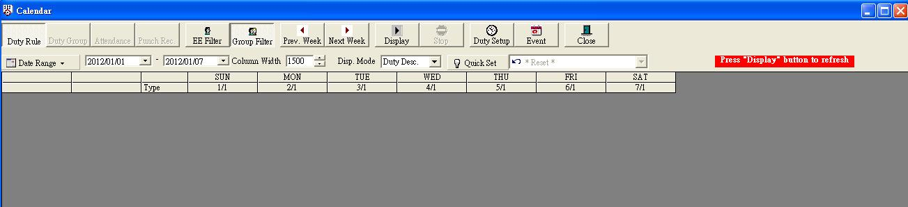
Calendar Setup > Duty Setup Menu
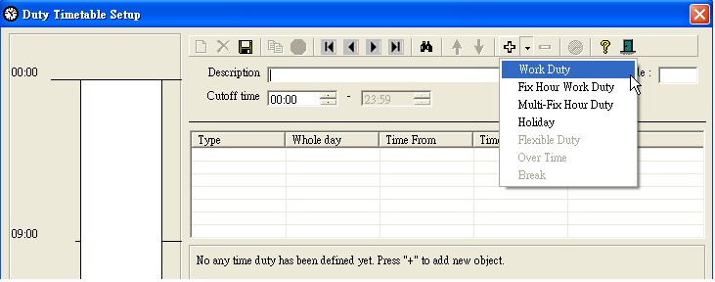

Calendar Setup > Duty Setup > Work Duty
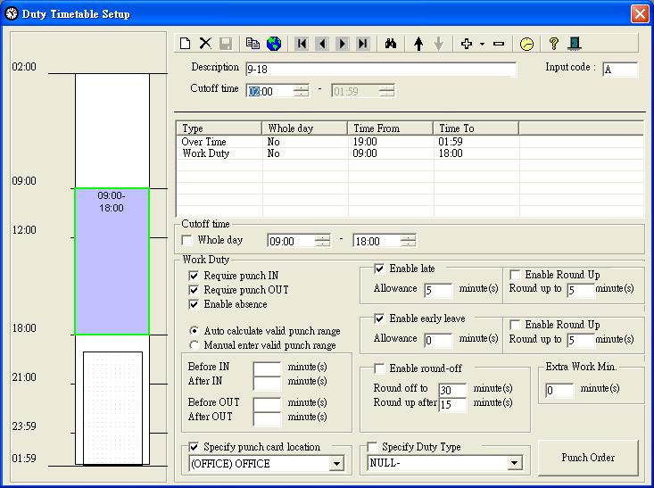

Calendar Setup > Duty Setup > Over Time
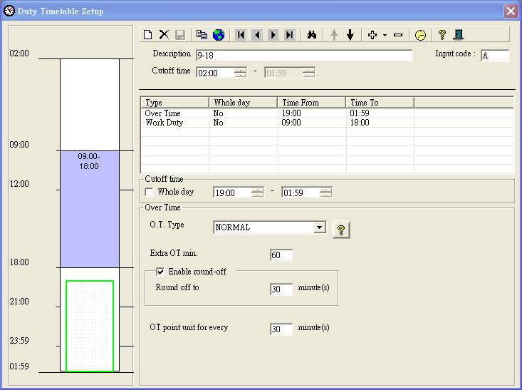

Calendar Setup > Duty Setup > Fixed Lunch Period
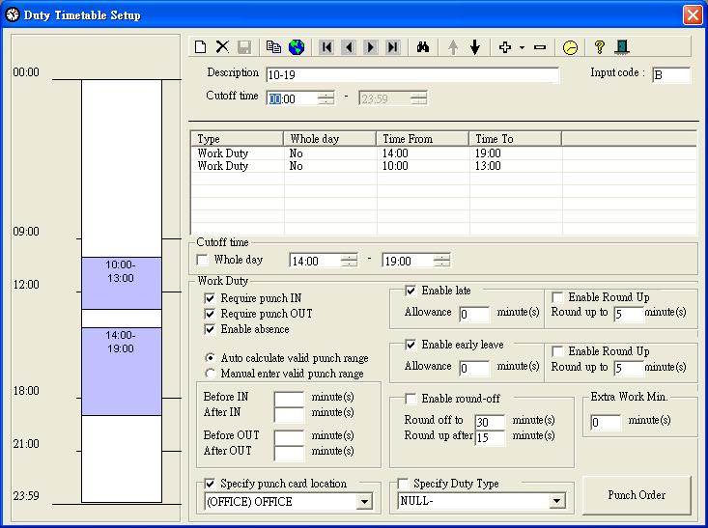

Calendar Setup > Duty Setup > Flexible Lunch Period
